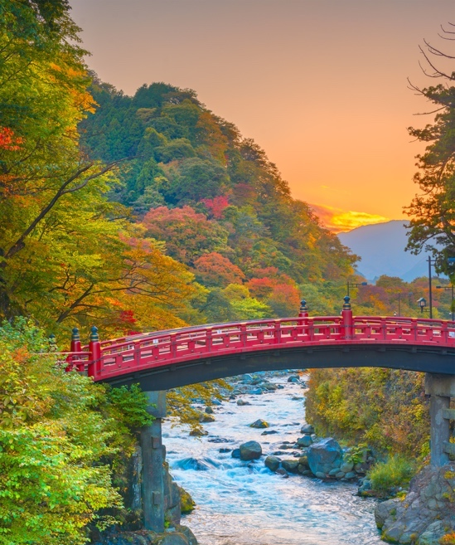
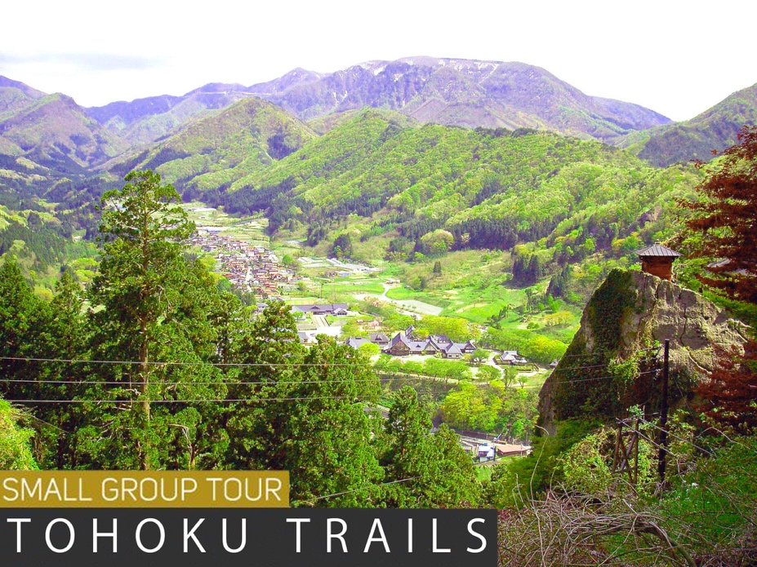
TOUR DOSSIER
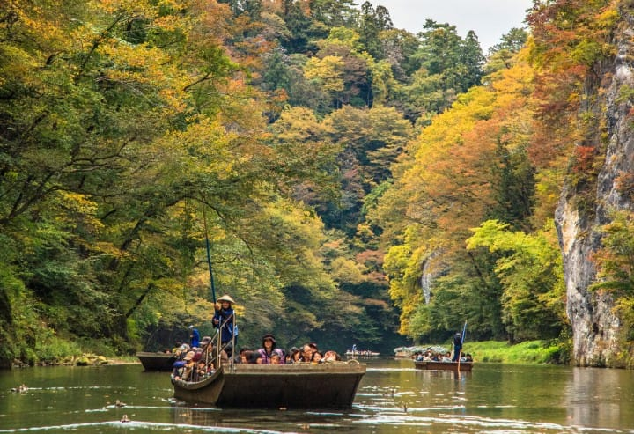
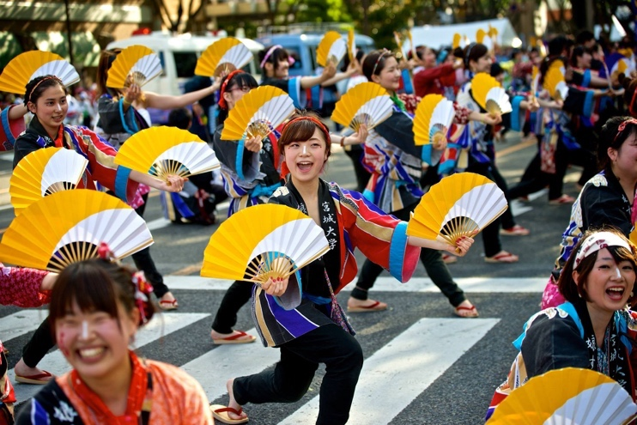

“Welcome to the start of your Unique Japan Journey!

Our team and I are really looking forward to planning your trip to Japan.
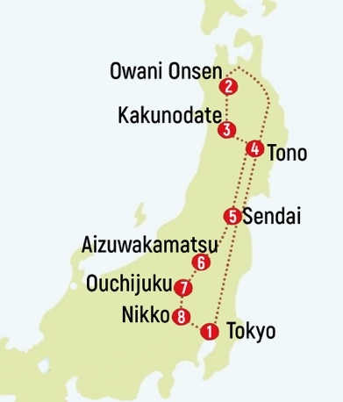
Tohoku Trails was designed to give you a wonderfully authentic Japanese experience, that is off the traditional international tourist trail, and yet packed full of incredible sights and activities. Discover the hidden gems (including 3 separate UNESCO world heritage sites) amongst the less travelled area of Tohoku, on the main island north of Tokyo.

Hike through native virgin forests to subline waterfalls. Soak in 300 year old volcanic hot springs and continue to step in the footsteps of ancient Buddhist monks, Shoguns, Samurai, and poets. Visit authentic samurai residences and shop in 400 year old merchant stores in villages that have been preserved like a time capsule.

Learn about the rich history of the last samurai and discover how the Bushido spirit lives on in the Aizu-Wakamatsu region. Visit family run farms to meet real Japanese people in the beautiful countryside and learn about their way of life. Ride the ultimate luxurious bullet train and old single carriage trains over stunning mountain scenery. Ride gondola boats through river ravines, row a boat over colourful carp on a stunning vibrant lake and take a boat cruise past hundreds of pine-tree covered islands in a pacific ocean bay.

By joining this tour, you will gain a fantastic insight into the Japanese arts, crafts, spiritual traditions, cultural customs and beliefs that are still alive today. Learn more about how Japanese people think, behave, and appreciate their natural surroundings and ancient treasures that remain significant influence on traditional practices and mindset of the people today.

I am happy to receive any questions you might have about this tour so please get in touch!”

Darina Slattery, Unique Japan Tours, Managing Director
Email: darina@uniquejapantours.com
Please quote the following reference when contacting us:
Tohoku Trails

We can be reached on any of these numbers:

IRL: +353 (0)1 6787008 UK: +44 (0)20-3239-2519 (9am – 5.30pm) USA: +1 347-688-3952 (8am – 3pm)
Email: info@uniquejapantours.com

CONTENTS

1. Why Choose Unique Japan Tours? 4
2. Tour Route & Departure Dates 5
3. Tour Itinerary 6
4. Destination Highlights 11
5. Tour Prices & Inclusions 16
6. What about our luggage? 17
7. Complimentary Services 18
8. Ready to BOOK! 18
9. Small Group Tours Checklist 19

Why Choose Unique Japan Tours?

- FULLY BONDED – FINANCIAL PROTECTION

Unique Japan Tours is a member of Total Payment Protection who fully guarantee and protect financial transactions between you and Unique Japan Tours. Your tour is fully protected no matter what country you are paying from. Full details of this will be clearly explained in our terms and conditions.

- Small Groups with NO MINIMUM NUMBER POLICY
Our groups have always been intimate in size. We prefer quality over quantity. For that reason, our average group size averages at 8-12 people (maximum 16 guaranteed). Since our tours started in 2007, and unlike many other operators out there, we have never cancelled a tour because of insufficient numbers. If we get less than the minimum number to run a tour (currently set at 6 people), don’t worry. We have years of experience designing a semi-escorted version of the same tour. The only difference to you will be instead of having a full-time tour leader throughout, you will be met on arrival at each destination by local guides and assistants - almost like your own private tour!! [See Inclusions on Page 14].

- Local Team with 24/7 Emergency Helpline

Our local company UJT Services G.K. [also owned by Unique Japan Tours], will oversee all operations of your trip from start to finish. Our team in Tokyo are busy working behind the scenes ensuring each tour runs smoothly, in real time! So, rest assured, no matter what your problem may be, we will be with you all the way. While on our small group tours, your tour leader &/or local guides will be your key contacts for any emergencies.

- 22 Years Experience in Japan

Our founder, Darina Slattery, first visited Japan in 1998, where she studied at Tokyo’s Meiji Gakuiin University. Today, she leads a team of Japan travel experts, working with hundreds of local suppliers in Japan directly, and selling tours to Japan globally. This invaluable knowledge and vast network of connections has resulted us being able to create the most amazing itineraries for people. All our tours are tried and tested ensuring our clients gain time, memories, & savings while on your trip.

- OUR CREW – JAPAN TRAVEL EXPERTS
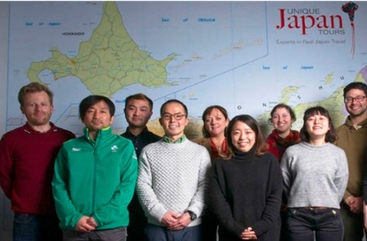
Our work ethic is family & customer focused. We are a team of Japan travel experts located in Tokyo, London & Dublin. Our clients come from all over the world so you can expect diversity in the group which always adds a bit of colour!

Let’s Zoom/Skype/Chat our way to finding you the best tour that suits you and your travel partners. We find speaking to you in person will save everyone time while ensuring you get the best tour suitable for you.

Tour Route & Departure Dates
Duration: 12 Nights / 13 Days
2021 Departures

- Oct 3 – 15 (Michinoku Yosakoi Festival)

“A tour created to showcase Japan’s past samurai, spiritual & farming traditions still living on strongly in the present ”.
2022 Departures

- April 16 – 28 (Cherry Blossom Season)
- July 31 – Aug 12 (Tanabata Festival & Nebuta Festival & Ichinoseki summer festival)
- Oct 02 – 14 (Michinoku Yosakoi Festival)

July & October Route
Tokyo [ 1 night ]
Owani Onsen
[ 2 nights ]
Kakunodate [ 1 night ]
Tono Farm Stay
[ 1 night ]
Sendai [ 2 nights ]
Aizu-Wakamatsu
[1 night]
Ouchijuku [ 1 night ]
Nikko [ 1 night ]
Tokyo [ 2 nights ]
April Route

Tokyo [ 1 night ]
Nikko [ 1 night ]
Ouchijuku [ 1 night ]
Aizu-Wakamatsu
[ 1 night ]
Sendai [ 2 nights ]
Tono Farm Stay
[1 night]
Kakunodate [ 1 night ]
Owani Onesn [ 2 nights ]
Tokyo [ 2 nights ]
On Tohoku Trails, immerse yourself in Japan’s ancient past whilst also experiencing some modern cities. Enjoy the incredible natural scenery with countless lakes, waterfalls, rivers, native forests, mountain ranges, coastal views, and islands. Learn about the rich samurai and spiritual past and discover how these traditions are kept alive and are still practiced in both rural and modern day Japan.

Avoid the crowd of tourists by traveling north from Tokyo instead of south towards Kyoto as most international visitors do. Only 1% of international visitors go to Tohoku, so the actual experience as a foreign visitor to the region would be akin to what is was like visiting Kyoto 30 years ago before its explosion as a must see spot in Japan.

Whilst you may forgo some of the popular UNESCO world heritage sites in Kyoto, you will instead discover some of the UNESCO world heritage sites located in less visited areas of Japan and get to enjoy them at your own pace.

Taste the incredible variety of foods, from the fresh seafood in Aomori (famously huge in size due to the extreme cold waters surrounding the coastline), to the world-famous beef in Yamagata and many other local delicacies (dare to try grilled cow tongue in Sendai station?), and treats along the way. Taste award-winning sake (rice wine) at brewery and enjoy the tour of the Kirin beer factory (which will become your favourite Japanese beer to drink back home)!

Appreciate the warmest of welcomes that are best earned when meeting local people in countryside locations that are off the beaten tourist path. Hike to temples perched on top of mountainsides, ride riverboat and ocean bay cruises and enjoy a mixture of western and traditional Japanese accommodations. Join in with the friendly locals and celebrate the different seasons and experience authentic Japanese festivals first hand.

This is the perfect tour for those in search of deeper cultural experiences that blend stunning nature, world-class hospitality, engaging history and culture, amazing culinary treats, and the warmth of the Japanese people.

(*) Supplement applies – see website for exact prices

- Tour Itinerary
 | Itinerary in Brief | Accommodation & Meals
DAY 1  Tokyo | Arrive in Tokyo Narita or Haneda Airport  You will be met on arrival by our airport transfer staff and taken to your hotel  We usually meet our fellow explorers 6pm in the hotel lobby. So try to arrive by at least 2pm on this day to make it on time for orientation.  Enjoy a welcome dinner with your tour leader & meet your new group at a local restaurant. | 1 Night  (Pre-Tour Nights available on request)  Shibuya Excel Tokyu  (or similar city centre 4*)  - Breakfast  - Welcome Dinner
DAY 2  Tokyo  ↓↓  Shin Aomori  ↓↓  Owani Onsen | Breakfast at your hotel  Transfer to Owani Onsen by “Granclass Shinkansen”; Japan’s ultimate luxury bullet train. Enjoy the longest journey of your trip – traversing all the way to the very north of Honshu by the highest class bullet train akin to first class cabin treatment on a plane.  Traveling at speeds of up to 320kph, but smooth enough so you’d barely think you are moving, if it wasn’t for watching the whole of the Japanese countryside fly past.  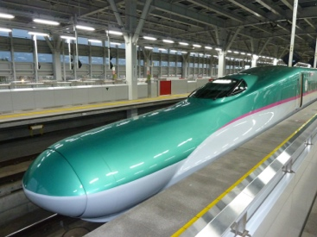  Evening at leisure at your top class Ryokan  HIGHLIGHTS  - Spectacular Kaiseki Dinner at your fabulous Ryokan  (one of the hightlights of the Japanese style accommodation)  - Granclass car: The ultimate luxury bullet train | 2 Nights  Hoshino Resorts Kai Tsugaru  - Breakfast  - Dinner
DAY 3  Owani Onsen | Breakfast at your hotel  ✪ Shirakami Sanchi Forest (UNESCO World Heritage Site)✪  What to expect:  - Shirakami Sanchi UNESCO World Heritage site Hike  - Nebuta Museum Wa Rasse  - Hirosaki Castle Park  (Spring: Hirosaki Cherry Blossom Festival)  - Aomori Museum of Art  - Auga Fresh Market  - Tsugaru-han Neputa Village  - Sannai-Maruyama Ruins | 2 Nights  Hoshino Resorts Kai Tsugaru  - Breakfast  - Dinner

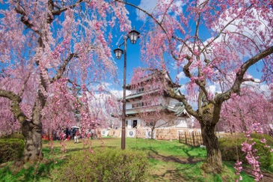
APRIL HIGHLIGHTS: Hirosaki Castle Cherry Blossoms
The cherry blossoms at Hirosaki Castle Park are famed as one of the best cherry blossom sights in Japan. Home to 2600 trees with over 50 different types of cherry blossom trees. Over 2,000,000 visitors visit the park during the Cherry Blossom Festival which usually lasts one to two weeks. Visitors enjoy festive food & drinks stalls, picnics together, and can even paddle small boats on the castle’s moat to view blossoms and castle reflecting off the water. At night, the trees look spectacular illuminated and so much of the grounds are carpeted in pink from the falling blossoms.

AUGUST HIGHLIGHTS: Nebuta Festival
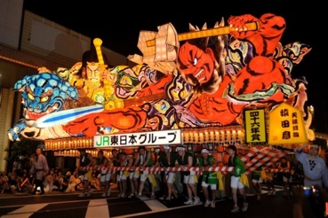
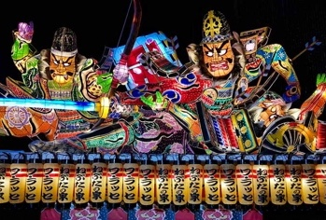
The streets of Aomori City come alive in summer with gigantic, vibrantly-colored floats depicting mythical legends and gods during the Nebuta Festival. The elaborate lantern floats, vividly illuminated from inside, are paraded around each day accompanied by dancers and taiko drums bellowing out thunderous tunes. They leer and sweep over the cheering crowds as teams of volunteers push the floats through the 3-kilometer circuit.

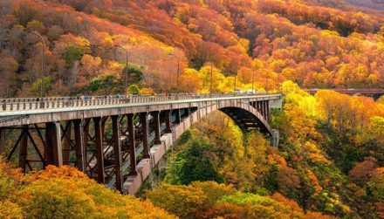
OCTOBER HIGHLIGHTS: Autumn Leaves Scenery

Enjoy the most spectacular autumn foilage views are you travel over the countryside The full day with a local guide and driver in a private van will enable you to stop and take beautiful photos such as at this famous bridge.
DAY 4  Owani Onsen  ↓↓  Nyuto-Onsen  ↓↓  Kakunodate | Breakfast at your hotel  Transfer to Nyuto-Onsen by Shinkansen & Bus  - Nyuto-Onsen Experience (Pay locally)  This is the ultimate Onsen experience, and if you left the big cities alarmed at the pace of modern Japanese life, a visit to Nyuto Onsen Tsuruno-yu will reassure you that traditional ways are very much alive and well in Japan.  Transfer to Kakunodate by Shinkansen or train  (Just 10 -20 minutes by either)  Transfer to Hotel by TAXI | 1 Night  Tamachi Bukeyashiki Hotel  - Breakfast  - Dinner
DAY 5  Kakunodate  ↓↓  Tono | Breakfast at your hotel  Transfer to Ichinoseki by Train and Shinkansen  ✪ Traditional Samurai Residence ✪  Half Day with local guide  Today we will visit Kakunodate Original Samurai Residences & Edo Era Merchant district with a private local guide for an interesting walking tour of the area.  - Bukeyashiki street  - Bukeyashiki Samurai residences  - Kakunodate Sakura (Cherry blossom) Festival on April Tour  Continue on to Tono by Shinkansens and Train  Homestay at a traditional Japanese family farm  - Farming, picking, cooking experience at a Japanese Farm  - Stay with a welcoming Japanese farm family | 1 Night  Agriturismo Omori-Ke (or similar farm homestay)  - Breakfast  Dinner

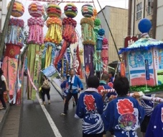
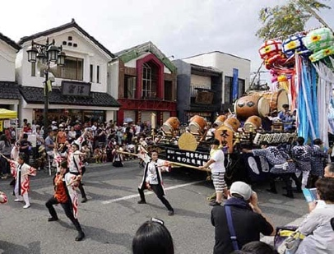
AUGUST HIGHLIGHTS: Ichinoseki Summer Festival
Ichinoseki locals love festivals. This is one of the best of the regional small town festivals. See the vibrant “Toki no Taiko” ("timekeeping drum") marches along an Omachi-dori Street lined with Tanabata ("star festival") decorations billowing in the breeze. In the evening, many groups clad in their original yukata costumes perform a massive parade dance called Kurukuru Odori down the street with a portable shrine festival.
SPRING HIGHLIGHTS: Kakunodate Cherry Blossom Festival
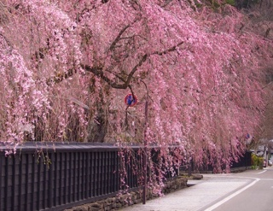
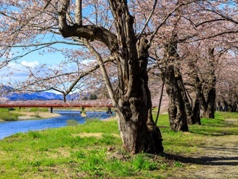
Kakunodate is one of the Tohoku region's most famous cherry blossom spots. Around one million people visit Kakunodate's cherry blossom festival each year. It was during the Edo Period (1603-1868), many of the 80 local samurai families imported weeping cherry trees from distant Kyoto, in an attempt to outperform each other in cultivating the most beautiful trees. Their efforts are still visible in the samurai district, where dozens of weeping cherry trees line the streets.

DAY 6  Tono  ↓↓  Ichinoseki  ↓↓  Sendai | Breakfast at your farm  Transfer to Ichinoseki by Train and Shinkansen  ✪ Chuson-ji Temple (UNESCO World Heritage Site)  & Geibiki Gorge River Cruise ✪  Half Day with local guide  What to expect:  - Chuson-ji Temple UNESCO World Heritage Site  - Geibikei Gorge River Cruise  - Ichinoseki Summer Festival (July Only)  Transfer to Sendai by Shinkansen  Evening at leisure in Sendai. Join your tour leader for a walk around taking in:  - Tanabata Big Fireworks Festival (July/August Tour)  - Iroha Yokocho (Street Food & Drinks) |  |  | 2 Nights  Richmond Hotel Premier Sendai Eikmae  - Breakfast daily
DAY 7  Sendai | Breakfast at your hotel  ✪ Yamadera & Matsushima ✪  Full Day with local guide  - Yamadera Mountain Temple  - Matsushima Bay  - Matushima Bay Boat Cruise  Suggested Itinerary  - Shopping  - Try Yamagata beef  - Drinking district in the evening time
AUGUST HIGHLIGT: Tanabata Festival
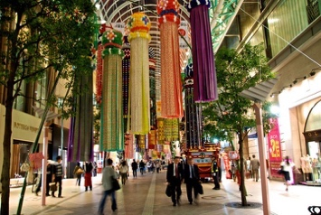

The Sendai Tanabata Matsuri is one of the largest and most famous tanabata celebrations in Japan and attracts over 2 million visitors each year. While festivities take place throughout downtown Sendai,(including a spectacular fireworks display) the festival's main feature are thousands of colorful streamers that decorate the city's shopping arcades.

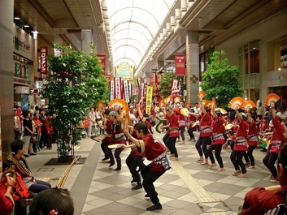
October HIGHLIGHTS: Michinoku Yosakoi Festival
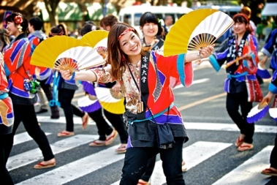
Yosakoi (よさこい) is a unique style of dance that originated in Japan and that is performed at festivals and events all over the country. They vary in size from small villages hosting a few teams of dancers in conjunction with another annual festival, to large cities like Sendai, which hosts the Michinoku Yosakoi Festival, the third largest festival in Japan.

DAY 8  Sendai  ↓↓  Fukushima  ↓↓  Koriyama  ↓↓  Aizuwakamatsu |  | Breakfast at your hotel  Transfer to Kirin Beer Plant for a factory tour & light lunch  Transfer to Fukushima Fruit Farm by Shinkansen & Car  - Fruit Picking (all you can eat style) In Fukushima, which is well known the “fruit kingdom” in Japan  Strawberry Picking (Spring)  Peach Picking (Summer)  Apple Picking (Fall)  Continue on to Koriyama station by Shinkansen  Transit at Koriyama Station  - Visit the skyscraper Big i building observatory (the tallest building in Fukushima and Planetarium in the world) at Koriyama station for the view.  Transfer to Aizuwakamatsu station by train  Digital Detox at your Ryokan Retreat :  - Relax in the Onsen  - Kaiseki Style Dinner  - Stunning garden and explore authentic Japanese Ryokan building | 1 Night  Aizu Higashiyama Onsen Mukaitaki  - Breakfast  - Lunch  - Dinner

DAY 9  Aizuwakamastsu  ↓↓  Ouchijuku | Yuttari Aizu Tobu Free Pass (4 days)  ✪ SAMURAI, SAKE & OUTDOOR ACTIVITY✪  Full Day with local guide  What to Expect:  - Tsuruga Castle Cherry blossom festival (Spring only)  - Iimoriyama (Sazaedo temple)  - Visit top Sake brewery (award-winning sake tasting)  - Nisshinkan former Samurai School  (Traditional Samurai training experience including  Japanese kyudo (archery), kendo, tea ceremony etc.)  - Goshikinuma 5 colored lakes: Stunning view of Mt Bandai, boat rowing & 4km light hike  - Taste Kitakata Ramen that is one of the best three ramens in Japan  Dinner (and perhaps some more sake) at your minshiku | 1 Night  Honke Ogiya (Minshiku)  - Breakfast  - Dinner
DAY 10  Ouchijuku  ↓↓  Yunokami Onsen  ↓↓  Nikko | Breakfast at your Minshuku  Morning Stroll at your own leisure  - Walk through the old traditional Japanese village where you can feel old Japanese lifestyles.  Transfer to Yunokami Onsen Station  - Dip casually into the foot bath at the station while waiting for your train.  Transfer to Nikko by Aizu Mount Express Train  - Enjoy the stunning countryside scenery over mountains and rivers from the train  Transfer to your Hotel – Luxury awaits! Brand new Ritz Carlton Nikko. Opened mid-2020, it represents the highlight of the western style accommodation on the tour! Enjoy | 1 Night  The Ritz Carlton Nikko  - Breakfast

DAY 11  Nikko  ↓↓  Tokyo | Breakfast at your hotel  ✪ NIKKO SIGHTSEEING✪  (UNESCO World Heritage Site)  Local Guide Sightseeing / Full Day  What to expect:  - Chuzenji Lake  - Nikko Toshogu shrine (UNESCO WHS)  - Kegon waterfall  - Italian & British Embassy Villa Memorial Park  Your last leg is back to Tokyo (just under 3 hour journey). More bullet/express trains.  Evening free time at your own leisure in Tokyo  *suggested itinerary will be available in your travel pack | 2 Nights  Shibuya Tokyu Excel Hotel  - Breakfast daily
DAY 12  Tokyo | Breakfast at your hotel  Enjoy a free day at your own leisure in Tokyo city  You will have the option to join your tour leader for a hop on/off the subway system around Tokyo. If you prefer to go alone, your tour leader can provide you with up to date real-time information on where to go and how to go there!  Evening Option:  Farewell Dinner at local izakaya (pay locally) | 2 Nights  Shibuya Tokyu Excel Hotel  - Breakfast daily
DAY 13  Options:  Tokyo  ↓  Airport  Or  Tokyo  ↓  Kyoto | Breakfast at your hotel  You will be picked up at your hotel for Haneda/Narita Airport  Depart from Tokyo on your scheduled flight  ~~ Tour Ends ~~  SAYONARA | 2 Nights  Shibuya Tokyu Excel Hotel  - Breakfast daily

Destination Highlights
Tokyo
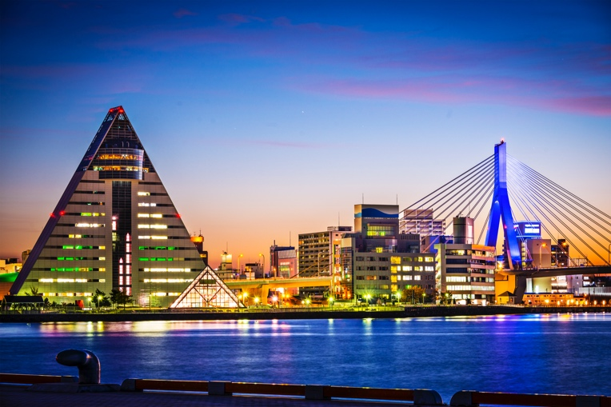
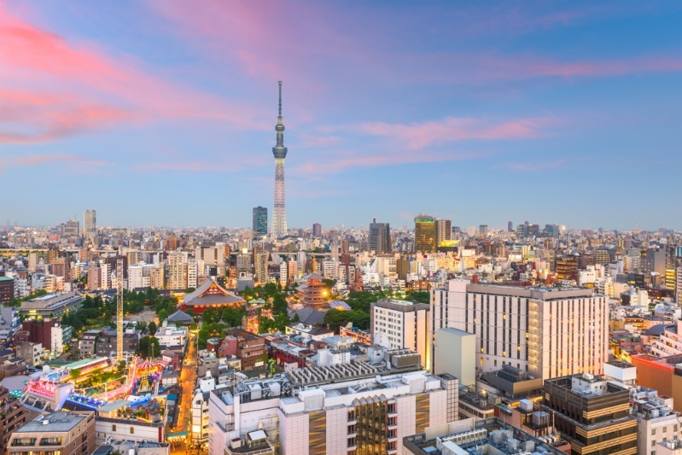
A quarter of all Japanese live in Tokyo or the near vicinity and with a population of over 36 million inhabitants, Tokyo metropolitan area is the largest city in the world. With its huge skyscrapers, underpasses, overpasses, and crowds of pedestrians, Tokyo may not seem the most attractive city on the surface, but the city has a vibrant charm all of its own. The street-level detail is what makes Tokyo such an incredibly interesting place to explore and at every turn, you will be met with an array of sights, sounds, and smells to enliven the senses. The city has many major sights to visit such as Senso-ji Temple in the old downtown area of Asakusa or the fashion hub of Shibuya from where all new trends are said to emanate. All in all a stay in Tokyo is to experience one of the world's most vibrant and interesting cities; a capital hurtling headlong into the future whilst maintaining its links with the traditions of ancient Japan.

Aomori
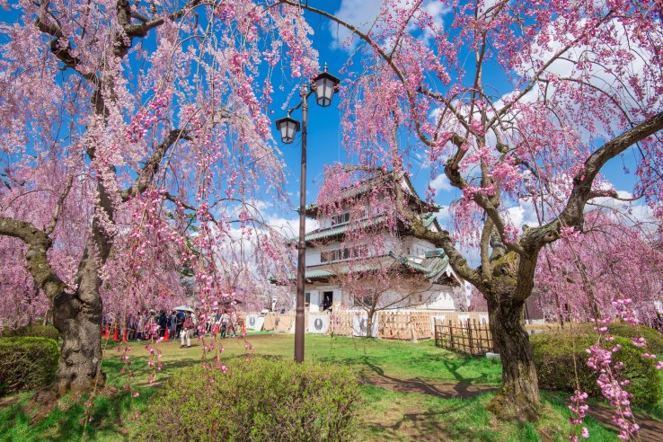
Aomori City is the northernmost prefectural capital city on Honshu, Japan's main island. An important port city, situated on Mutsu Bay, Aomori is bordered by the Hakkoda mountain range. Humans have inhabited the prefecture for at least 15,000 years, and the oldest evidence of pottery in Japan was discovered at the Jōmon period Odai Yamamoto I site. The city centre is home to craft shops, department stores, and trendy clothing stores on the side streets. It is also home to an old fashioned market with an array of stalls selling a variety of fish and mountains of Aomori Prefecture's most famous product: delicious oversized apples.

Relatively unexplored, Aomori's natural landscapes, famous festivals, and World Heritage sites can all still be called “hidden gems.” Hiking through unspoiled wilderness, riding in trains heated by stoves and sampling delectable seafood and sake are just a few of its attractions.

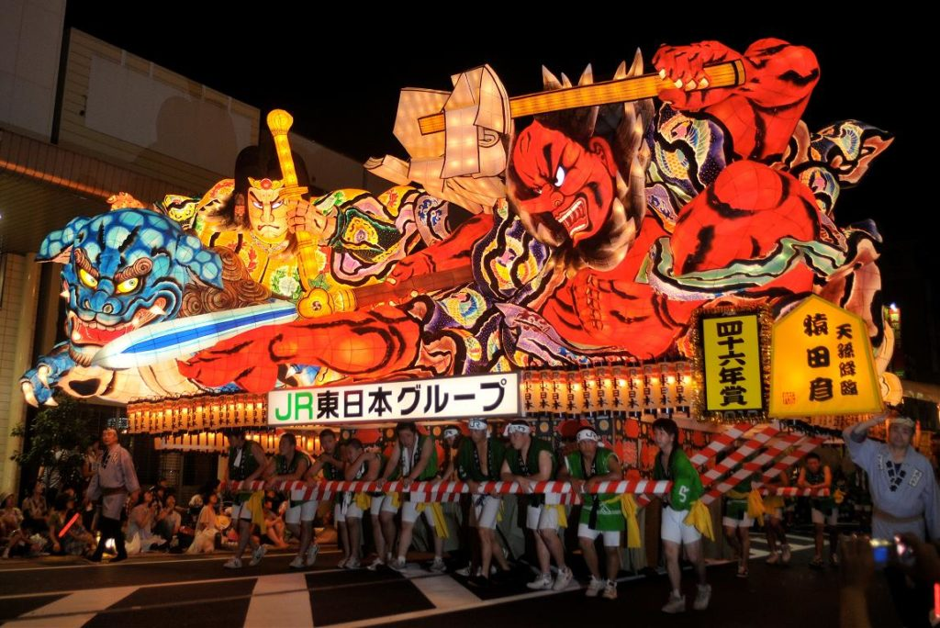
The city boasts unrivaled seafood from the cold waters of both the Sea of Japan and Pacific Ocean and Aomori’s local Specialties include Tsugaru Lacquerware, Aomori Black Garlic, Tsugaru Painted Kites, Aomori Apples & Ichigo-ni (a seafood stew)

Today Aomori is best known for it’s spectacular Nebuta Matsuri summer festival. Although it is only held over a few days in August, the gigantic bamboo framed lanterns of various forms (including samurai, kabuki actors, and sumo wrestlers) are displayed in an exhibition all year round.

Shirakami Sanchi UNESCO World Heritage Site

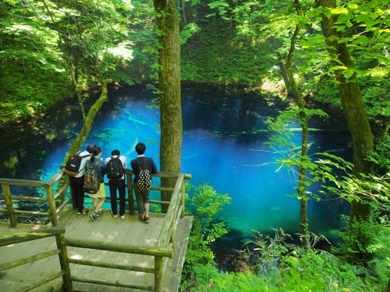
Shirakami Sanchi is an extensive mountain range straddling the border between Aomori and Akita prefectures in the northern Tohoku Region of Japan.

The largest remaining virgin beech forest in East Asia; Shirakami Sanchi is made up of the last virgin beech forests in Japan, for which the region was declared one of the country's first UNESCO World Heritage Sites in 1993. It is a remnant of the cool-temperate beech forests that have covered the hills and mountain slopes of northern Japan since eight to twelve thousand years ago.

Fauna found in the area includes Japanese black bear, the Japanese serow (a type of goat antelope), Japanese macaque (monkeys), and 87 species of birds (including Black woodpecker, Mountain hawk-eagle, and the Golden eagle) can be found in this forest. The main attractions of Shirakami Sanchi are the various hiking trails that lead through the forests to stunning waterfalls and pristine beautiful lakes that are easily accessible on foot.
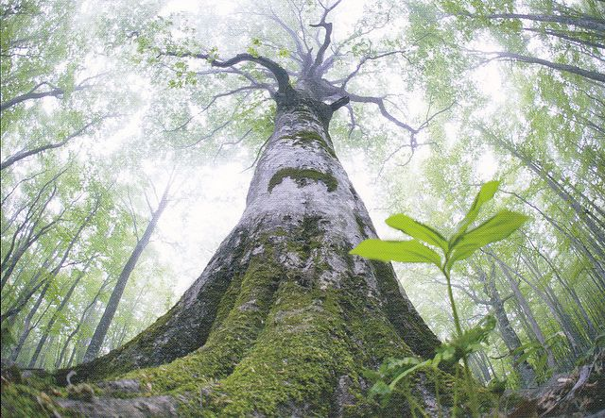
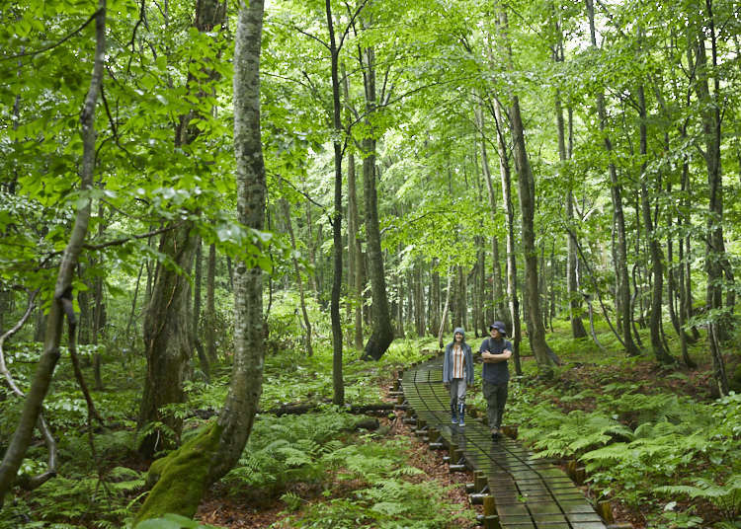
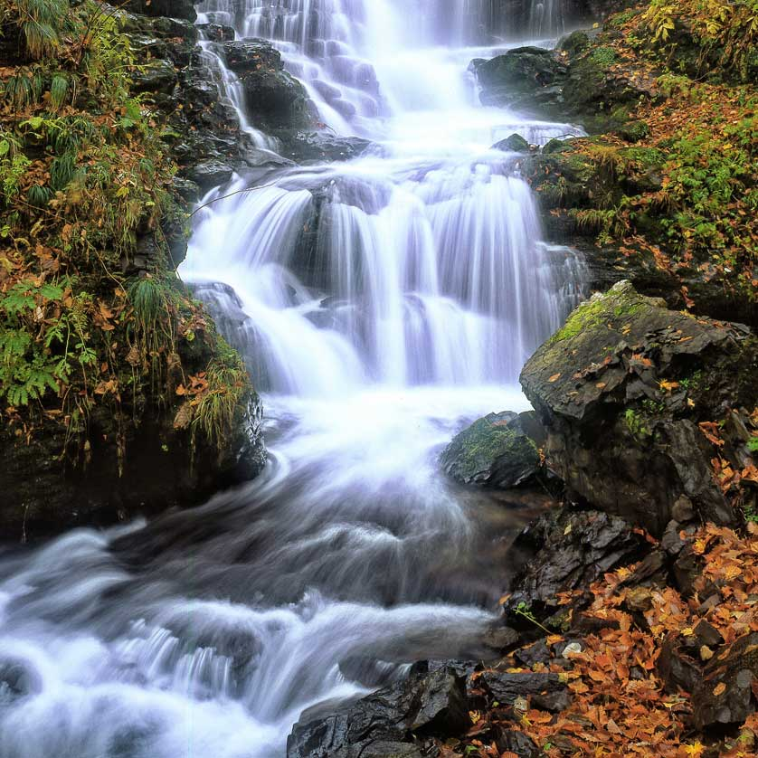
Kakunodate
Kakunodate sometimes referred as 'the little Kyoto of Tōhoku', looks today much as it did back in 1620 when the city was founded. Kakunodate boasts authentic Edo-period architecture in two distinct areas; the samurai district and the merchant district. Once home to 80 families, the samurai district still has some of the best examples of samurai architecture in all of Japan.

A couple of the houses are still lived in by the descendants of their samurai, so you may even get the chance to meet a modern-day samurai in the flesh! These houses show how middle-class and wealthy samurai families lived. Six are open to the public, including Aoyagi, which is impressive for its size, layout, and collection of historical artifacts.

The countless weeping cherry trees in the samurai district were planted in the 17th century, brought back from Kyoto by local samurai families. Nowadays, more than a million people journey to see Kakunodate's thousands of cherry trees bloom, making it one of the country's most famous hanami or cherry blossom viewing spots.

Take advantage of the commanding views looking over the town from the former castle site. Explore Japan's feudal past & shop at 400-year-old stores. The impressive brick structure of the Ando Jozo Miso storehouse stocks miso and soy sauce, which have been produced using the same method for over 150 years. Buy some to take home a taste of history. Before you leave, be sure to grab some of the town's traditional sweets, called morokoshi. Made from refined adzuki beans, they make a delicious souvenir.
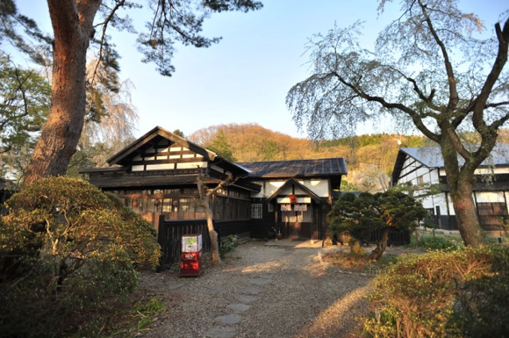

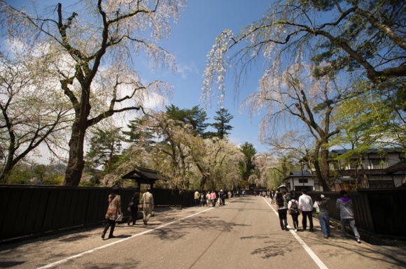

Nyuto Onsen

Northern Tohoku is one of Japan's most mountainous areas and an area rich with volcanic hot springs. Nyuto Onsen is an area known for the superb hot spring baths found at its traditional and rustic ryokan (traditional Japanese guesthouses). With a history of over 300 years, Tsurunoyu is Nyuto Onsen's oldest and most famous inn. It features a collection of dark wooden buildings, which are hidden away at the end of a 2km dirt track with only a small sign on the main road indicating its presence.

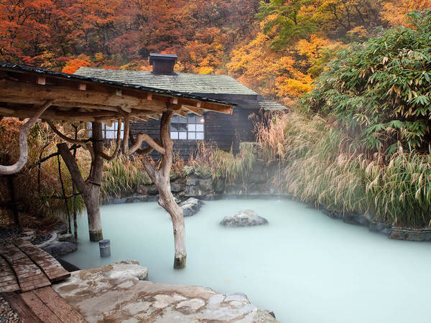
Outdoor bathing in nature is an incredible experience in all seasons, but in summer, thousands of flowers blossom around you, whilst in autumn the many colours of the changing leaves make for a stunning natural backdrop. There is a range of both indoor and outdoor baths to enjoy, with the largest outdoor bath being used by both men and women together. Don’t worry due to the volcanic mineral content of the area's hot spring water, it has a milky/cloudy appearance which makes mixed-gender bathing less intimidating than it would seem.

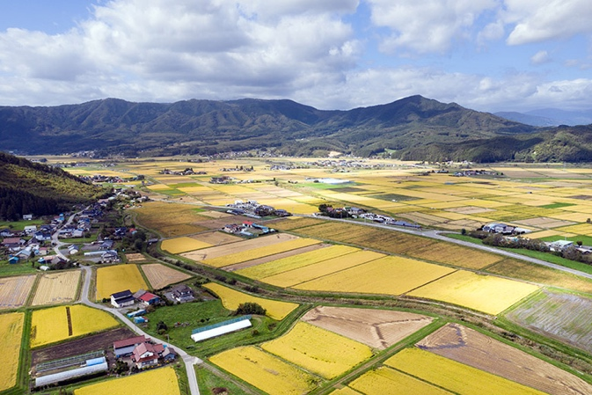
Tono
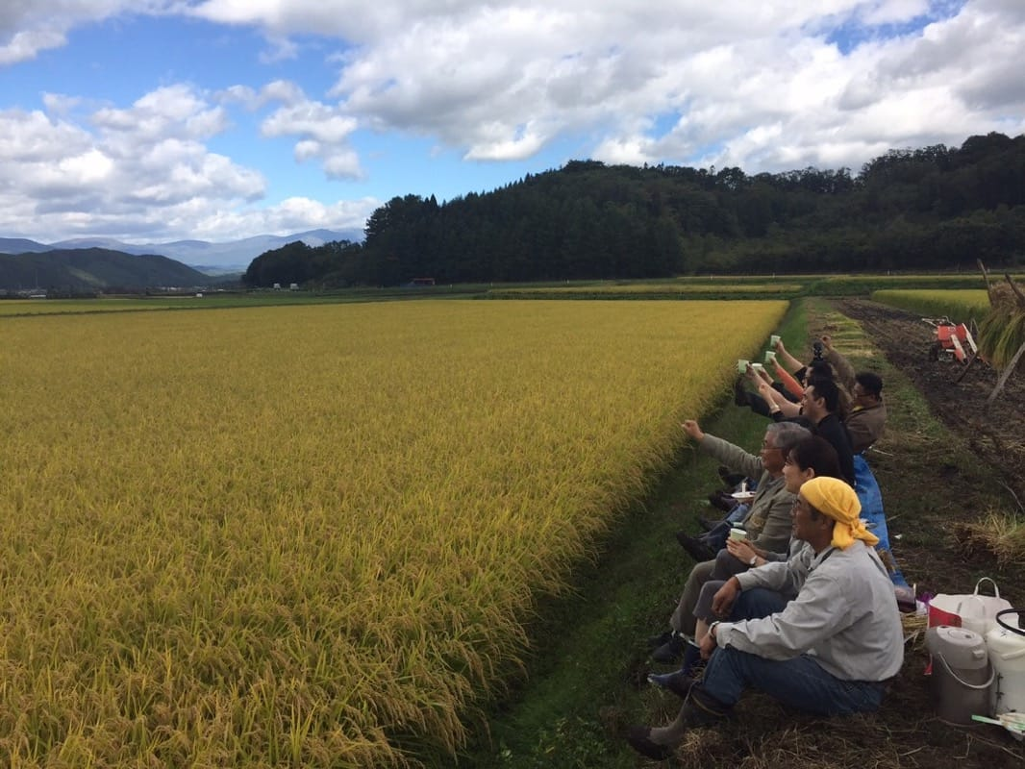
Rural Japan is still alive and well—and in Tono, a small town in the rustic prefecture of Iwate, it’s intimately connected to nature and local history. Here, civilization dates back over two millennia and still maintains an antiquated atmosphere. You’ll find thatched-roof houses in this natural, agrarian setting built on the floodplain of the Sarugaishi River and surrounded by a circle of mountains. Tono is where traditional culture and “old-time country life” lives on among its simply idyllic landscapes. Tono is famous for its folktales, old legends, and mysterious stories that feature spirits, ghosts, and other imaginative creatures like Kappa.

Experience the traditional Japanese lifestyle by doing some work on a real Japanese farm. Try light fieldwork with peanuts, flowers, and vegetables or various other farm tasks depending on the season. In doing so, you make real connections with the farming family and share in their lifestyle.

Geibikei Gorge River Cruise
Geibikei is a ravine (approx. 2km long) on the Satetsu River in the city of Ichinoseki, Iwate Prefecture. The river is surrounded by soaring cliffs of over 50 meters in height, and peaking at 124 meters, with fanciful rock formations created by erosion and numerous waterfalls.

Enjoy the serene beauty of Geibikei while being serenaded by the drivers of Venetian-style boats. The best way to see the spectacular scenery for yourself is to take a flat-bottomed boat ride along the waters. Men and women propel the boats in much the same way that the gondolas in Venice, are propelled. Drivers point out famous sites along the way and serenade their passengers with a traditional folk song written especially for the occasion.

The gorge is especially picturesque in autumn during “Koyo” or the changing of the leaves. You can buy special food to feed the river carp and ducks along your journey. A 90 min long flatbottomed boat tour along the Geibikei Gorge makes for a great change of pace from modern Japan. Geibikei has been designated a National Place of Scenic Beauty and Natural Monument since 1923 and in 1927 it was also selected as one of the 100 Landscapes of Japan.
Chuson-Ji Temple UNESCO World Heritage Site
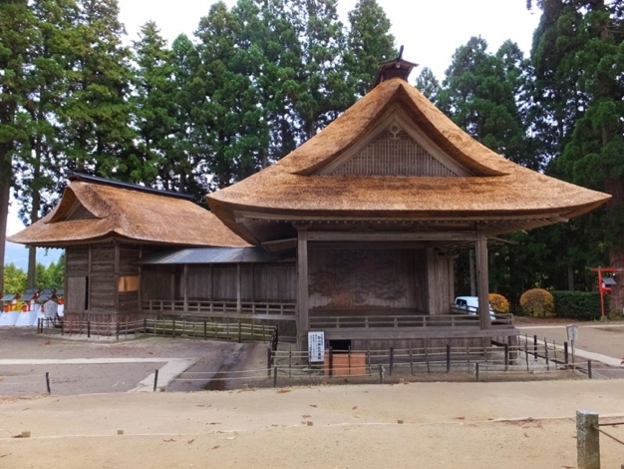
Founded in 850, Chūson-jí is a Buddhist temple in the town of Hiraizumi in southern Iwate Prefecture, Japan. Chūson-jí was designated as a Special Historic Site in 1979 and in June 2011 was listed as a UNESCO World Heritage Site as a part of the "Historic Monuments and Sites of Hiraizumi".

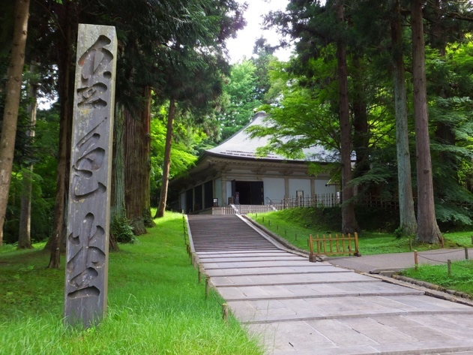
Similar to Kinkaku-ji Temple in Kyoto (but without the crowds of fellow tourists), Chuson-ji's main hall is covered entirely in gold leaf. The hall, known as Konjikido and which dates back to 1124, is enclosed inside another building for safe-keeping. Inside, Konjikido shrine is lavishly embellished the decorations use mother-of-pearl inlays, woodwork, metalwork, lacquer-work, and paintings, bringing together many aspects of late Heian period arts and crafts. It represents the peak of the craftsmanship of the classical period. It also serves as a clear reminder of the region’s history of mineral wealth and gold production, and by some historical accounts, may have been an inspiration for Marco Polo’s writings of “the golden land of Zipang”.

In the 12th century, Lord Kiyohara of the Fujiwara clan undertook a large-scale construction project to expand the temple in memory of the lives lost during previous wars. At its height, Chuson-ji had more than 40 halls and pagodas, and 300 residences for monks. The temple complex declined after 100 years during a period of political strife. Only two temple structures survived a massive fire in the 1300s.
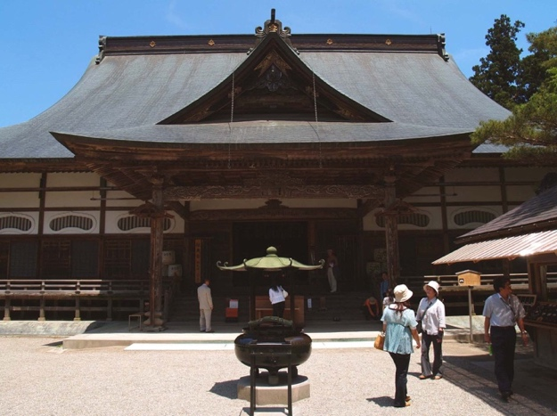
The Sankozo Museum (also called the Treasure Hall) opened in 2000 to preserve Chuson-ji’s historic treasures. More than 3,000 important cultural properties and national treasures are housed here, such as Buddhist statues, scriptures, and other relics that survived the devastating fire. When the Fujiwara clan fell, Hiraizumi's influence waned and the golden hall is one of the few remaining structures from this period causing the haiku master Matsuo Basho to write:
The summer grass
is all that's left
of ancient warriors' dreams.

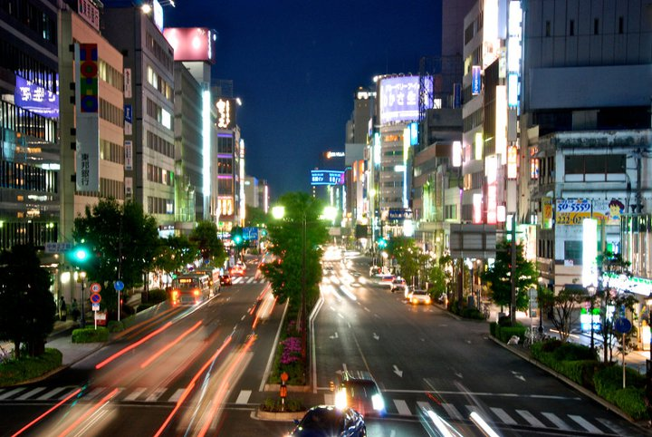
Sendai
With roughly one million inhabitants, Sendai is by far the largest city in the Tohoku region and one of the country's 15 largest cities. The samurai benefactor Date Masamune (one of feudal Japan's most powerful lords) is synonymous with founding Sendai in 1600, and his lasting legacy is a ruined castle set in pleasant gardens. Many of Sendai's tourist attractions are related to Masamune and his family and the city’s samurai history is displayed in well-preserved historical sites and architectural treasures.

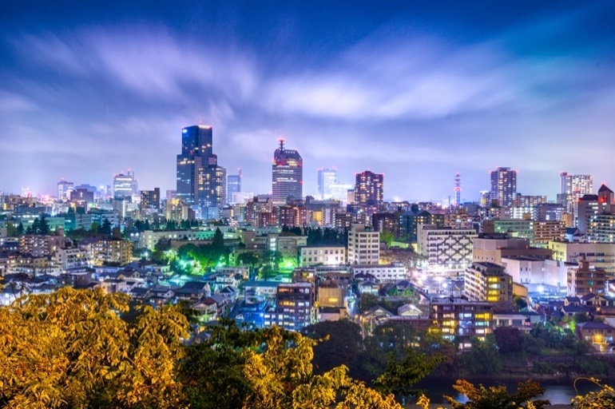
Due in part to being bombed heavily during WWII, the city has a modern feel with wide tree-lined boulevards that have a European feel. The compact city center and grid-like streets aligned north-south and east-west allow for easy access on foot to dining and shopping options. Those seeking some retail therapy can check out the upscale Izumi Premium Outlet, or take a short 18-minute train ride to experience the largest outlet shopping center in Tohoku, the 120-store Mitsui Outlet Park. For traditional crafts including kokeshi dolls, stop by Shimanuki, near Sendai Station.

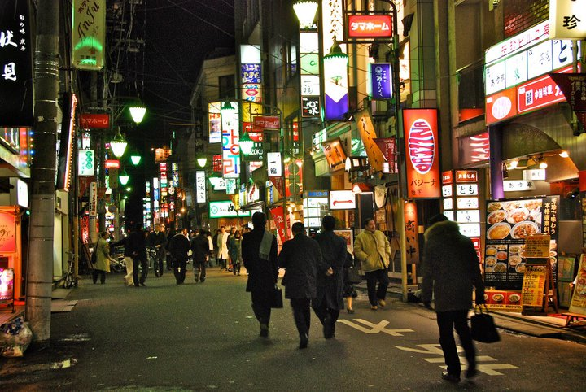
The main shopping and entertainment area is around Ichibancho Avenue, where there is a reasonable selection of shops, bars, cafes, restaurants, and clubs. Finish your day with some fine dining or a few drinks in Kokubuncho, Sendai's nightlife district packed with over 2,500 bars and restaurants. The nightlife district is impressive for a relatively small city.

Grilled beef tongue, or gyutan, is the local specialty and a must-try for meat-eaters. There are many restaurants specialising in grilled meat and gyutan around the station area. If you're not in the mood for meat, zunda, a sweet green soybean paste, is the other local favorite and used to top everything from mochi rice to ice cream parfaits. Sendai is the surprising home to a piece of hamburger history. Located among the bustling bars and clubs of Kokubuncho is Hosoya's Sandwich, possibly Japan's oldest hamburger restaurant, still serving up classic American-style burgers to this day.

Sendai was the closest major city to the epicenter of the earthquake of March 11, 2011. The tsunami devastated the city's coastal outskirts but did not cause major damage in the city center. Virtually all tourist spots reopened within a few months of the earthquake.

The city's wide, tree-lined streets fill up in summer for spectacular Tanabata Matsuri, one of Japan's most famous festivals. Sendai's big annual event, the Tanabata festival is held from 6 to 8 August.

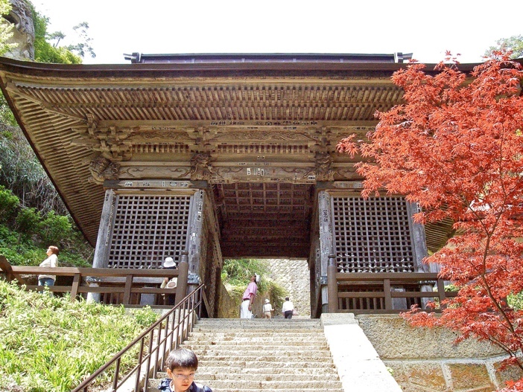
Yamadera
Just a short train ride from Sendai city, Yamadera literally means 'mountain temple' which is a descriptive name for this atmospheric temple complex clinging to the steep mountainside. Founded in 860, you'll have to climb 1,015 steps cut into the side of a mountain to reach the Okunoin, the heart of this mountain temple complex. The climb is kept interesting with many shrines and artifacts to observe along the way up and rewarded with spectacular views of the countryside valley down below.

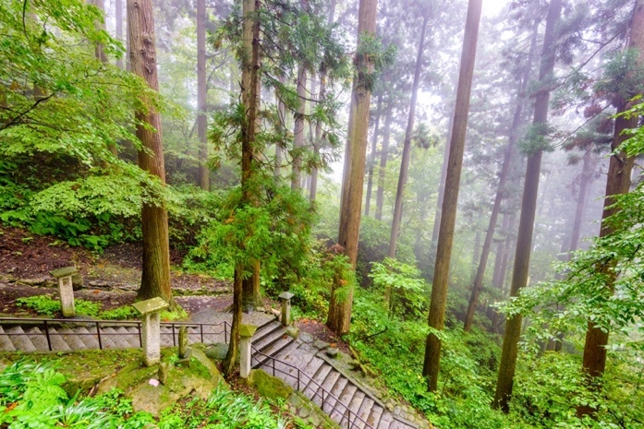
Before or after your climb be sure to spend some time in the village at the foot of the cliff, where you will find tiny local shops, restaurants, and plenty of vendors selling “miso-dango”; Yamadera's local specialty (chewy rice cakes covered in a spicy miso paste and grilled over charcoal).

Tohoku's most famous visitor the haiku master Matsuo Basho wrote these lines on visiting Yamadera:
Ah this silence
sinking into the rocks
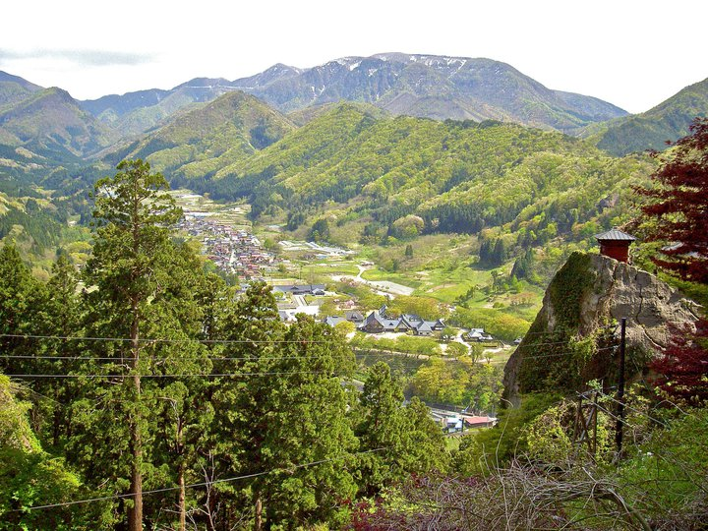
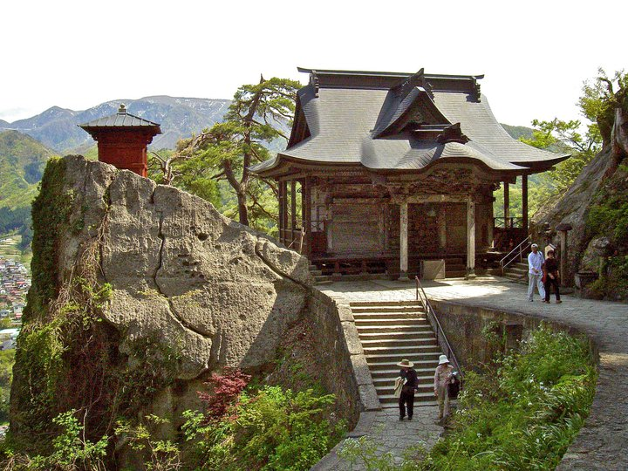
voice of cicada.

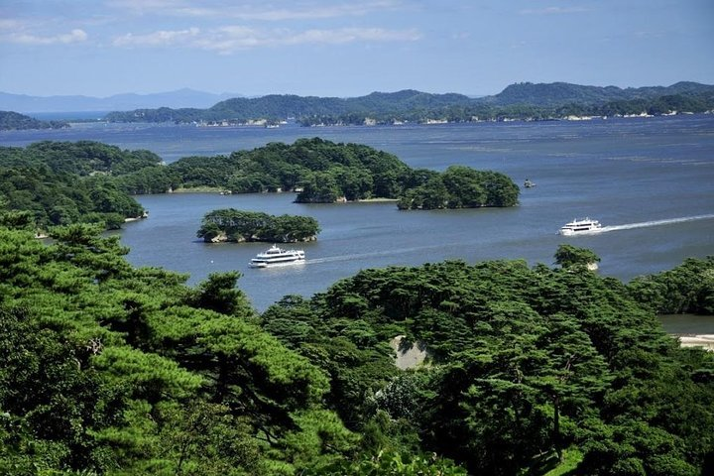
Matsushima
Located half an hour outside of Sendai, Matsushima is famous for its bay. For hundreds of years, Matsushima Bay has been celebrated as one of Japan's three most scenic views (alongside Miyajima and Amanohashidate). The bay is dotted by over 200 small islands covered by pine trees. The small town is also known for Zuiganji, one of the Tohoku Region's most important Zen temples.

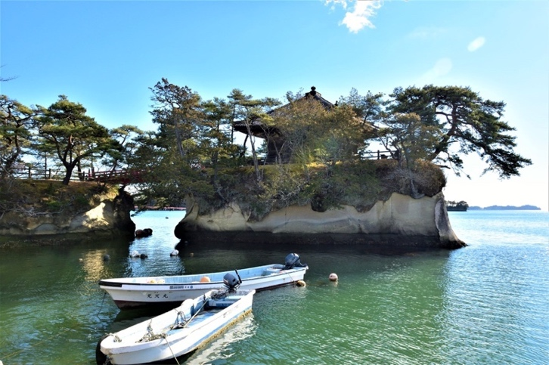
Matsushima was hit by the earthquake and tsunami of March 11, 2011, but escaped major damage thanks to its protected location inside the island-dotted bay. Most tourist attractions, shops, and hotels reopened within a few weeks or months of the earthquake.

Famous for its sea views and sunsets, you can try the local foods, all while walking around the tourist-friendly Matsushima shoreline. Enjoy close up views of the hundreds of pine tree-covered islands in the bay on a sightseeing boat cruise (approx 50mins).
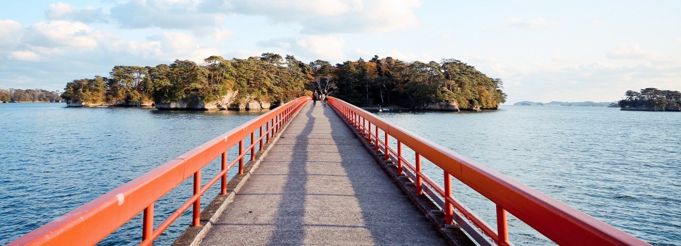

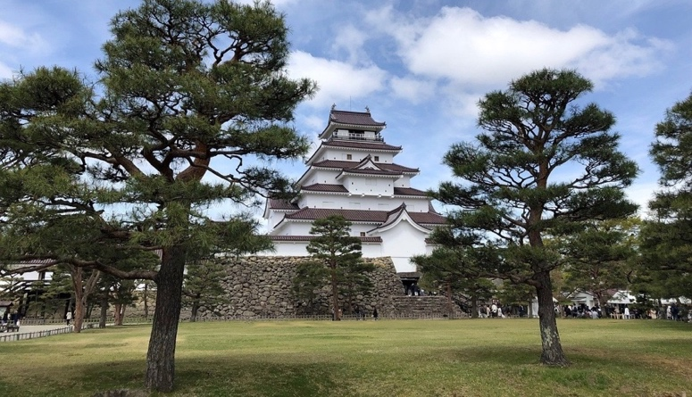
Aizu-Wakamatsu
Surrounded by scenic mountains, Aizu-Wakamatsu in western Fukushima Prefecture is a bustling former castle town with friendly locals deeply proud of their history and culture. The region is known for its pristine landscapes, quality sake, traditional crafts, and rich samurai history. Enjoy exploring Aizu Wakamatsu's winding little streets walking in the footsteps of past samurai.

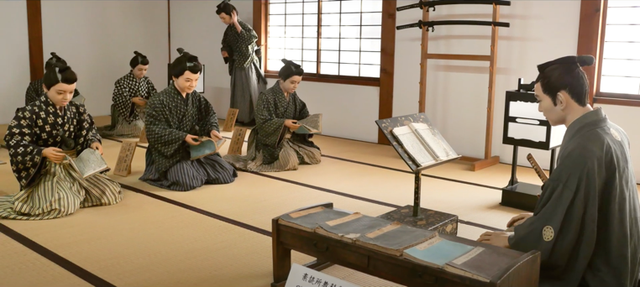
Renowned for its award-winning sake distillery and as being the refuge of the last samurai, Aizuwakamatsu is worthy of history buffs and sake lovers alike. Aizu is naturally blessed with three important qualities for sake making; high-quality rice, pure water springs, and cool weather. Suehiro is one of the largest sake producers in Tohoku and there are hourly tours around the brewery in the centre of town.

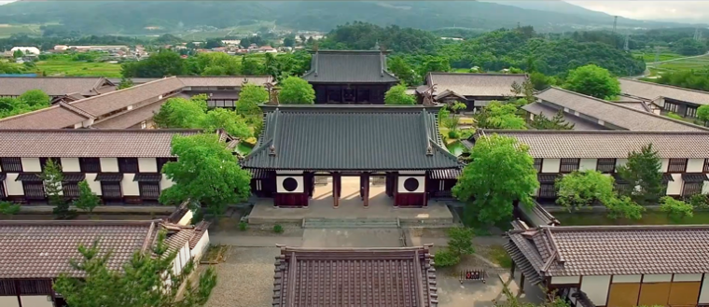
Today visitors can soak up samurai culture at the reconstructed Tsuraga-jo Castle, as well as the old samurai residences and Nisshinkan. Tsuruga Castle was built in 1384 and changed hands many times between the different rulers of the Aizu region. It was destroyed after the Boshin War of 1868, a rebellion against the newly formed Meiji government, which had taken over control from the Tokugawa shogun and put an end to Japan's feudal era. Tsuruga Castle was one of the last strongholds of samurai loyal to the shogunate.

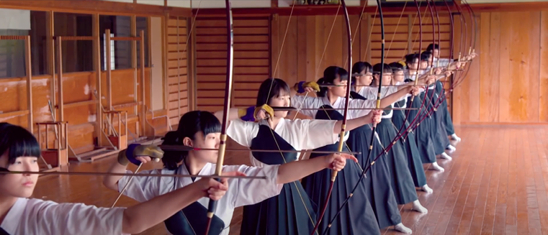
While the castle has been rebuilt in the 1960s, the garden's walls and moats are original. Climb to the top floor of the castle keep and look out onto the surrounding city. The inside of the building is an interesting museum with attractive displays about the history of the castle and the samurai lifestyle.

The castle is surrounded by the immaculate Tsuruga Castle Park, filled with beautiful cherry blossom trees. A visit to the castle is especially worthwhile during the cherry blossom season in early April when the gardens are alive with vibrant white and pink colors. Be sure to take a relaxing break at Rinkaku Teahouse in the park. After you view the beautiful historic teahouse, you can enjoy some great traditional tea in the same spot where feudal lords once had tea ceremonies.

Goshikinuma
Located in the Bandai-Asahi National Park, Goshiki-numa is a cluster of five volcanic lakes situated at the foot of Mount Bandai in Fukushima prefecture. Goshiki-numa formed when the Volcano Mount Bandai erupted on July 15, 1888, destroying dozens of villages while creating hundreds of lakes.

The eruption imparted mineral deposits to the Five Colored Lakes giving each of them its own delicate color, ranging from reddish-green to cobalt blue. The colors of each lake mysteriously fluctuate throughout the year with the weather. The different minerals and pH levels give the waters a number of striking colors. The weather and time of day provide even greater variation to these shades.

There are approximately 30 marshes and lakes in total. The walking trail is a quintessential Japanese tourist spot and offers stunningly beautiful views of all five lakes along the 4km walking path from Lake Bishamon (the largest of the five lakes) to Lake Hibara. Colorful carp inhabit the waters of Bishamon; a large colorful lake with multi-colored koi fish. Rent a rowboat to experience the lake close up and feed the carp from the boat.

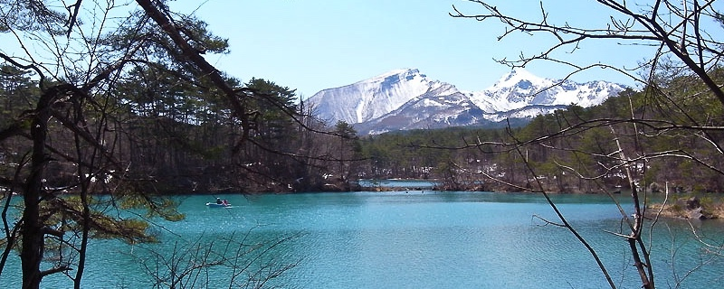
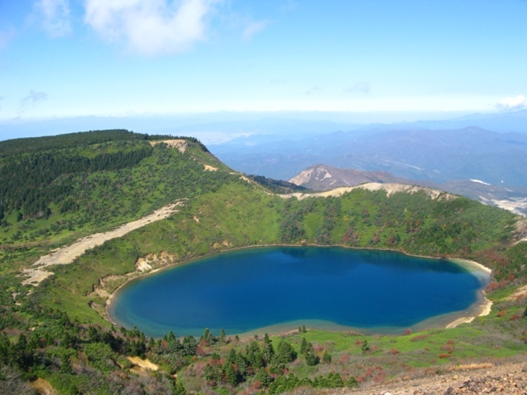
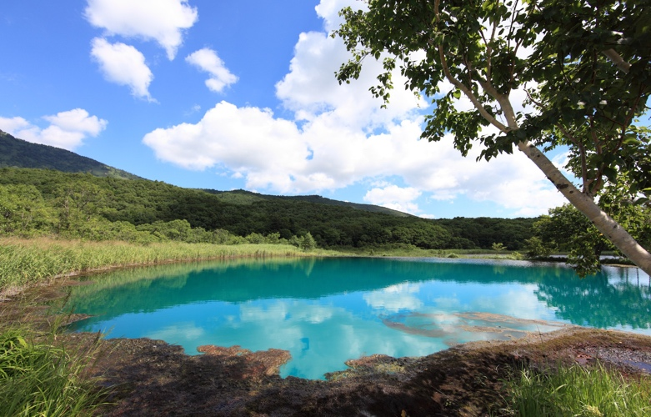

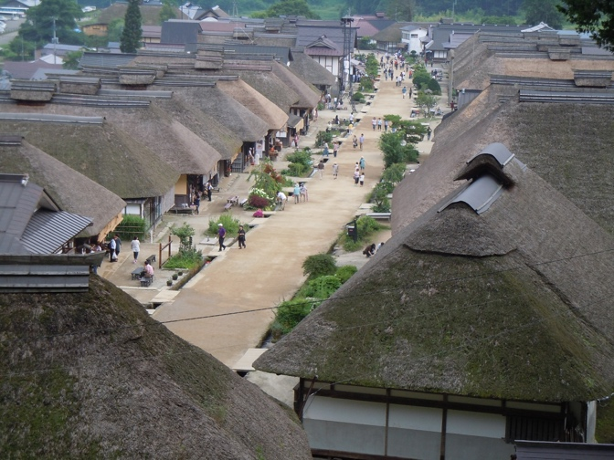
Ouchijuku
During the Edo period (1603-1867) Ōuchijuku was a “post town” along the Aizu-Nishi Kaido trade route, which connected Aizu with Nikko during the Edo Period. Post towns dotted the long road to Edo where rural samurai went to procure rice and food supplies. They would walk for several days on the road, and then stay the night in one of these post towns along the way.

Ouchi-juku is filled with buildings that are over 300 years old, with traditional thatched roofs and streets with running water to either side. At the end of the main road is a short but steep set of stairs that leads to a temple. From the temple, you can see a beautiful panoramic view of Ouchi-juku in its exquisite mountain setting.
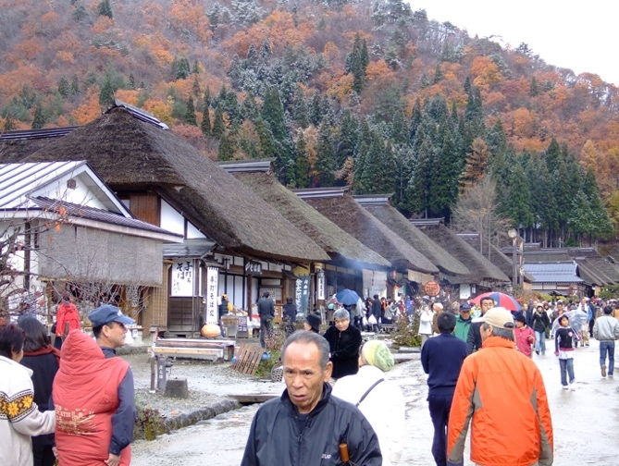
Today, Ouchijuku has been restored to look as it did hundreds of years ago, with telephone and electricity wires buried. Many of the buildings have been preserved from this time, providing visitors with an authentic time-travel experience to one of Japan's most culturally rich periods. The unpaved main street is lined by thick thatched-roof buildings.

The over 30 remaining thatched roof houses in Ouchi-juku that were once farms are now stores and souvenir shops. You can enjoy a variety of light snacks that have been loved since the Edo period, including scallion buckwheat noodles, char fish grilled in a sunken hearth, and the fragrant and sticky sweet potato rice cakes.

The town’s traditional buildings are now officially protected. Visitors can travel back in time to the Edo period as they walk along the row of thatched-roof homesteads. Traditional lifestyles can be seen inside the houses with various displays such as old-fashioned Irori fireplaces and the homewares of the era. There is also a museum with Edo Period artifacts.

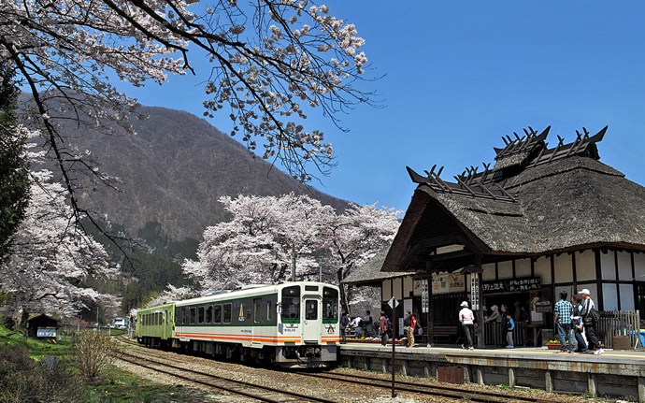
Yunokami Onsen

Yunokami Onsen is a famous railway station on the Aizu Railway Aizu Line. It is the only train station in Japan with a thatch roof. The half-timbered thatch roof station building has an “irori” open hearth fire in the waiting room.

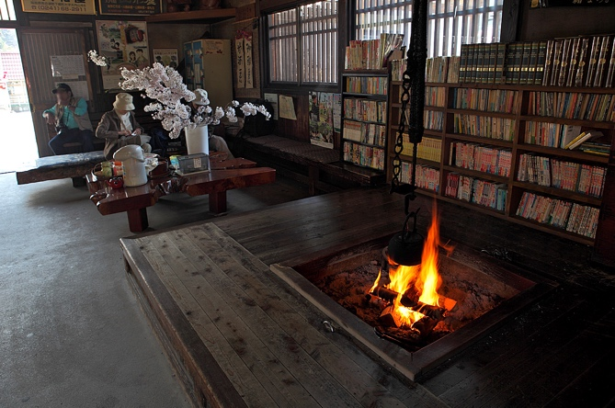
The area around the station is also famous for its rows of cherry trees. In April when the cherries bloom, many people visit to see the beautiful combination of the thatched station building, together with gloriously blooming cherries and passing trains. Spring is not the only time to visit, as each season has its own unique appeals that enhance the beauty of the station: the dark green of the mountains in summer, the golden leaves arrayed across the mountains in autumn.

Next to the station building is the Oyakojizo-no-yu foot bath that is fed by a natural spring, enabling you to dip your feet in the warm water and relax. During the cherry blossom season, visitors can enjoy a warm foot bath while watching the light pink petals fluttering in the wind.

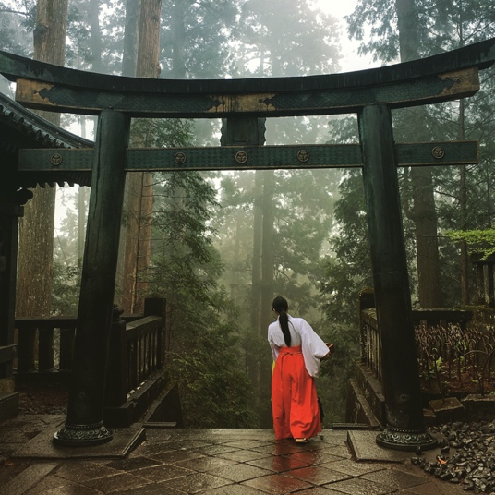
Nikko UNESCO World Heritage Site

The UNESCO World Heritage Site Shrines and Temples of Nikkō encompasses 103 buildings or structures and the natural setting around them. The whole property area encompasses 23 buildings of Futarasan-jinja Shrine, 42 buildings of Toshogu Shrine, and 38 buildings of Rinnô-ji Temple. Nine of the structures are designated National Treasures of Japan while the remaining 94 are Important Cultural Properties. UNESCO listed the site as World Heritage in 1999.

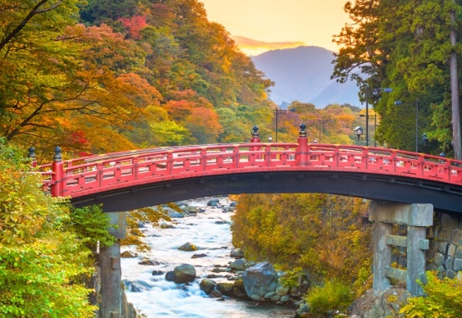
Futarasasn-jinja Shrine and Rinnoji Temple were both founded by Buddhist monk Shodo Shonin in the782AD. The temple complex has numerous structures linked together by serene mountain paths and showcases numerous artifacts and monuments, a Japanese style garden, and priceless artifacts such as gold lacquered statues of three Kannon deities.

Spread across an expansive natural landscape in Tochigi Prefecture, Nikko is a testament to one of the most important figures in Japan's history. Tokugawa Ieyasu (ruling from 1603 to 1605) was the first shogun of the Tokugawa Shogunate and is credited with bringing 300 years of peace and stability to the country after a long period of regional conflict. The famed shogun's remains are entombed at Kunozan Toshogu Shrine.

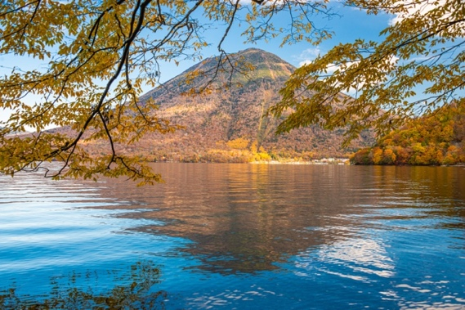
In a true display of Tokugawa Ieyasu's importance, as many as 127,000 craftsmen were involved in constructing the shrine memorializing him using the highest level of technology available at the time. The complex is made up of over a dozen structures, including a five-story pagoda, Honjido Hall, and the brilliantly colored Yomeimon Gate.

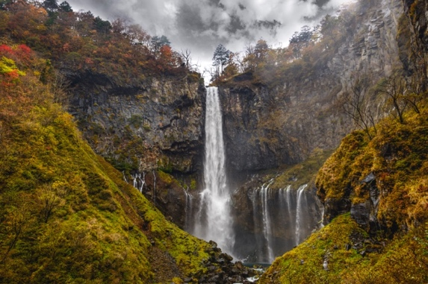
Walk across the 28-meter-long iconic wooden Shinkyo Bridge that serves as the sacred entrance to Nikko. The structure is known as one of the top three bridges in the country, and the vermilion-lacquered arch surrounded by lush foliage and a serene river makes for a particularly beautiful photo.

The Chuzenji Lake at the inner part of Nikko has been created by an eruption of Mount Nantai. From the Meiji period (1868-1912) until the early Showa period (1926-1989), it attracted lots of foreign diplomats who built their summer residences there.

There are a lot of waterfalls in Nikko, but Kegon Falls is by far the most famous and even made it to Japan's best waterfalls top 3. In true Japanese style, mixing modern and ancient, take an elevator to the observation deck to get a closer look at the base of the falls.

Tour Prices & Inclusions

Land Package Prices:

Triple Room Sharing: €TBD | £TBD | US$TBD | AU$TBD
Twin/Double Sharing: €TBD | £TBD | US$TBD | AU$TBD
Single Occupancy*: €TBD | £TBD | US$TBD | AU$TBD

*If you are willing to be paired up with another solo traveler, enquire with your travel consultant. While we cannot guarantee this option, we will do our best to find you a suitable room mate.

All prices are per person and subject to change at the discretion of the company.
Check website www.uniquejapantours.com for up-to-date & guaranteed prices.
Once deposit is paid, your tour price is fixed. Book Now.

Price Inclusions:

Hotels & Ryokans  (12 nights) | 6 Nights combination of Boutique, Superior & Deluxe Western Hotels  5 Nights Ryokan & Minshuku(Japanese style)  1 Night Home stay on an authentic Japanese Farm
Fully Escorted  (6 – 16 persons):  Semi Escorted  (1 – 5 persons): | You will be escorted by our English speaking tour leader.  If your group is less than 6 people, you will be doing the tour on a semi-escorted basis (Met in each area by our local assistants and guides).
Meals: | - Breakfast daily  - 6 evening meals  (taste the seasonal local produce from each region where you stay)
Private Tour Guides: | Private Guides in Aomori, Kakunodate, Ichinoseki, Sendai, Aizuwakamatsu, and Nikko.
Getting Around: | - Reserved Seats on all long-distance trains  - Several Luggage transfers (one bag per person)  - Chartered vehicles, local taxis/minivans/coaches on private city tours  - Arrival & departure airport transfers to & from hotel
Entrance Fees: | Included into all sights listed on itinerary
Cultural Experiences:
- Tokyo mega city experience
- Granclass car Shinkansen: The ultimate luxury bullet train
- Hiking in a virgin native forest (UNESCO World Heritage Site)
- Aomori Museum of Art & Nebuta festival Museum
- Overnight stays in traditional Japanese style accommodation with kaiseki dinner
- Hirosaki Castle Park in Aomori City
- Multiple Stunning Onsen / Hot Spring retreats (including the stunning Nyuto-Onsen)
- Kakunodate samurai village guided tour
- Japanese traditional kimono dressing and rickshaw ride
- Sake tasting and sake brewery tour
- Tono authentic farm experience
- Hiraizumi UNESCO World Heritage Site including Chuson-Ji Golden Temple
- GeiBeiki river gorge gondola boat ride
- Sendai City shopping & drinking district pub crawl
- Yamadera Mountain Temple Hike
- Matushima Bay Boat Cruise
- Kirin Beer Factory Tour
- Seasonal Fruit Picking in Fukushima
- Sky scraper Big i building observatory (view from the tallest building in Fukushima)
- Tsuruga Samurai Castle & grounds tour
- Iimoriyama (Sazaedo temple)
- Visit top Sake brewery (award-winning sake tasting)
- Goshikinuma crater lake viewing, light hike & rowing boat trip
- Taste Kitakata Ramen (one of the best three ramens in Japan)
- Nisshinkan former Samurai School (Traditional Samurai training experience)
- Explore Ouchijuku Stray Roof Village (preserved 300-year-old traditional Japanese village)
- Aizu Mount Express Scenic Train Journey
- Nikko temples and shrines, lakes & waterfalls etc (UNESCO World Heritage Site)
Seasonal Festivals/Events: | - April – Hanami Cherry Blossom Viewing Parties  - August – Japanese huge Firework Festival, Tanabata Festival, Nebuta Festival & Ichinoseki Festival  - October – Michinoku Yosakoi Festival

What about our luggage?

When using express trains on our small group tours, we will send your large suitcases on to the next hotel (usually skipping one night). Your itinerary will clearly highlight when this will be required. On these days, you will need a small overnight bag to bring with you (similar to a carry-on bag for flights). Although this service is reliable & efficient, Unique Japan Tours cannot take any responsibility for guests’ baggage. Each passenger will be required to carry your own bags at all times. Tour leaders will not be responsible for bags. Some hotels will have porter service but not all.

Complimentary Services
UJT’s Additional Services:
- Pre-Tour Travel Consultant
- Comprehensive tailor-made travel pack
- Local Emergency Contact
- All taxes and service charges
- Financial Protection
Not Included:
- Meals & Beverages (not listed on itinerary)
- International Flights (request quote)
- Tour Guide / Driver Gratuity (optional)

“At UJT, our aim is to be open and honest with all of our travellers. We hate hidden costs so will tell you where and when you will need cash while on the go!”
Darina Slattery, UJT Owner/Manger

UJT’s Essential Travel Pack
At Unique Japan Tours we aim to make your adventures in Japan run as smoothly as possible. To facilitate this, we will provide a detailed Travel Pack, tailor-made for your specific trip including:

- Tips, hints and information covering subjects as diverse as transport, food, language and bathing etiquette!
- Detailed step-by-step itinerary including hotel names (in both English and Japanese – good to have for taxi drivers) and daily suggested itineraries with clear details on how to make this happen!
- Customised access maps with bi-lingual train times and full instructions for every journey you will be making in Japan.
- Destination guides giving you up to date information on each place you visit.
- Local Area Maps, Vouchers, and Emergency contact details.
Any other information you have specifically requested from us.

Ready to BOOK!
To secure your place on Tohoku Trails Tour we require a booking deposit of:
€400 / USD500 / GBP350 / AUD600 per person
Pay Deposit Online: https://www.uniquejapantours.com/book-a-tour/
Tour Reference: Booking Deposit
Tour Name: Tohoku Trails
Small Group Tours Checklist
When? | What to do: | Tick when complete:
Before paying deposit: | Read and agree our full Terms & Conditions | ⃝
When ready to book: | Pay Booking Deposit (Payment Link) | ⃝
After paying deposit up to 7 days: | Receive pro-forma invoice outlining schedule of payments. Check it. Complete Booking Form and send (with copy of passport) to your travel consultant | ⃝
After paying deposit : | Take out personal/medical Travel Insurance. Send your policy name and details to your travel consultant | ⃝
After paying deposit (up to 8 weeks prior): | Book your flights as soon as you have your tour secured with us (or before if you find a good deal)  Send E-Ticket to your UJT Travel Consultant | ⃝
8 weeks prior | Tour Balance is due 8 weeks prior to the tour starting date. Pay online or by bank transfer. Details will be on your Pro-forma invoice. | ⃝
2-3 weeks prior | Wait for your Travel Pack including full pre-departure details.  We will send to the postal address you provide us with. Your travel consultant will be in touch before this time to confirm address. | ⃝
Pre-Departure | Final check you’ve sent all Essential Documents to your travel consultant:  Flight E-Tickets, Dietary Requirements (if any), Insurance Policy Name/Number, Passport Copy, Emergency Contact Name/Number | ⃝

As a result of the prolonged restrictions caused by Covid-19 Pandemic, scheduled tour dates may be affected. Website dates will be kept up-to-date. As of January 2021, we are unsure when Japan will open up its borders. However, don’t let that stop you plan your dream trip for later on in 2021 and indeed into 2022/2023. All deposits are refundable if we cannot operate a tour due to Covid.

